**SQL queries For Table 1**

1. Retrieve properties with balconies, sorted by the number of bedrooms in descending order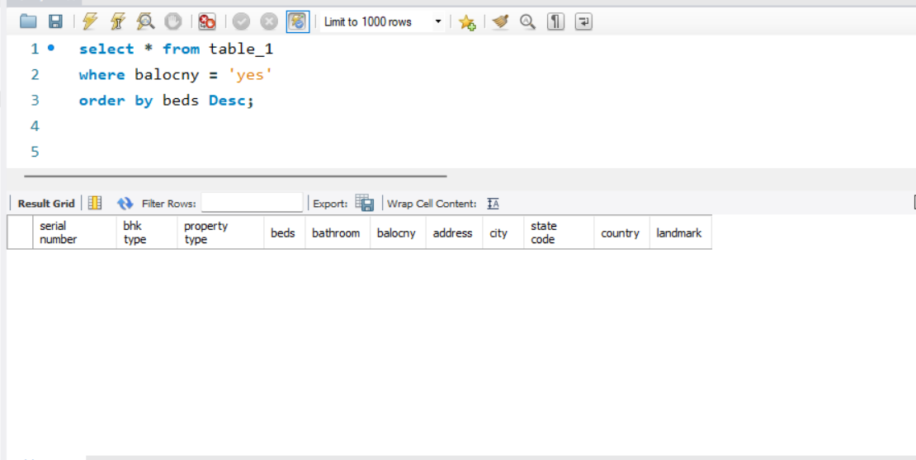
2. Find the top 5 cities with the highest average number of bedrooms per property

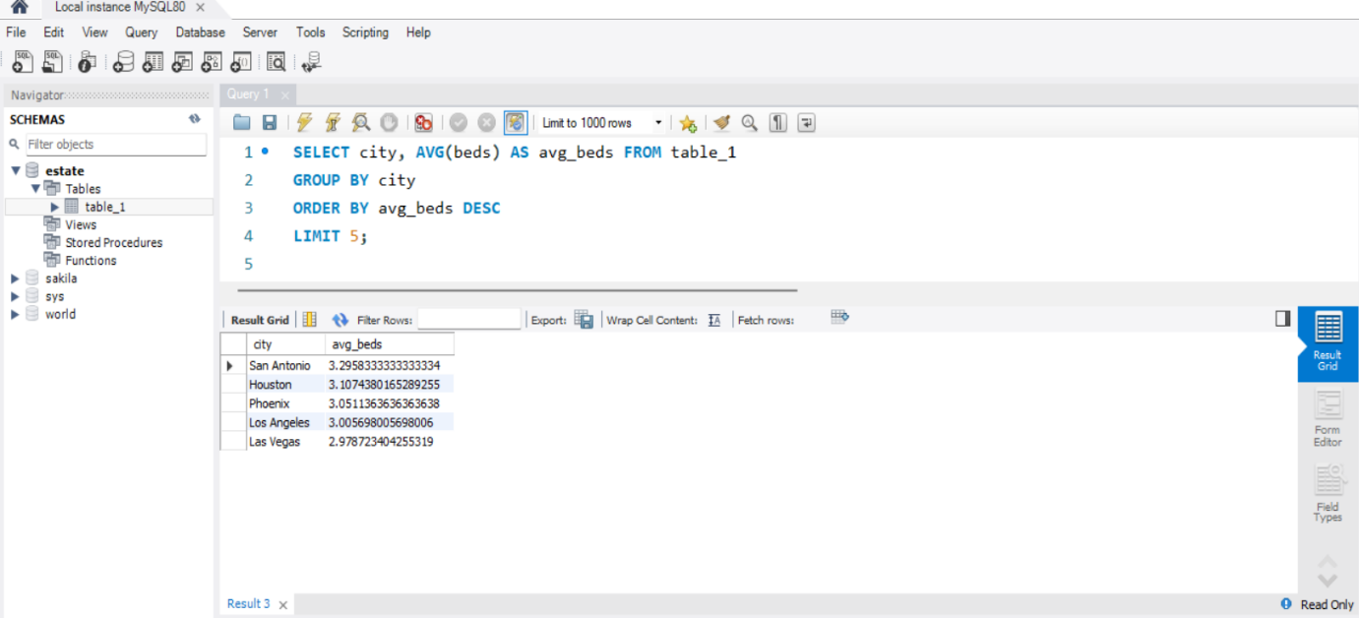

1. Count the number of properties in each city.

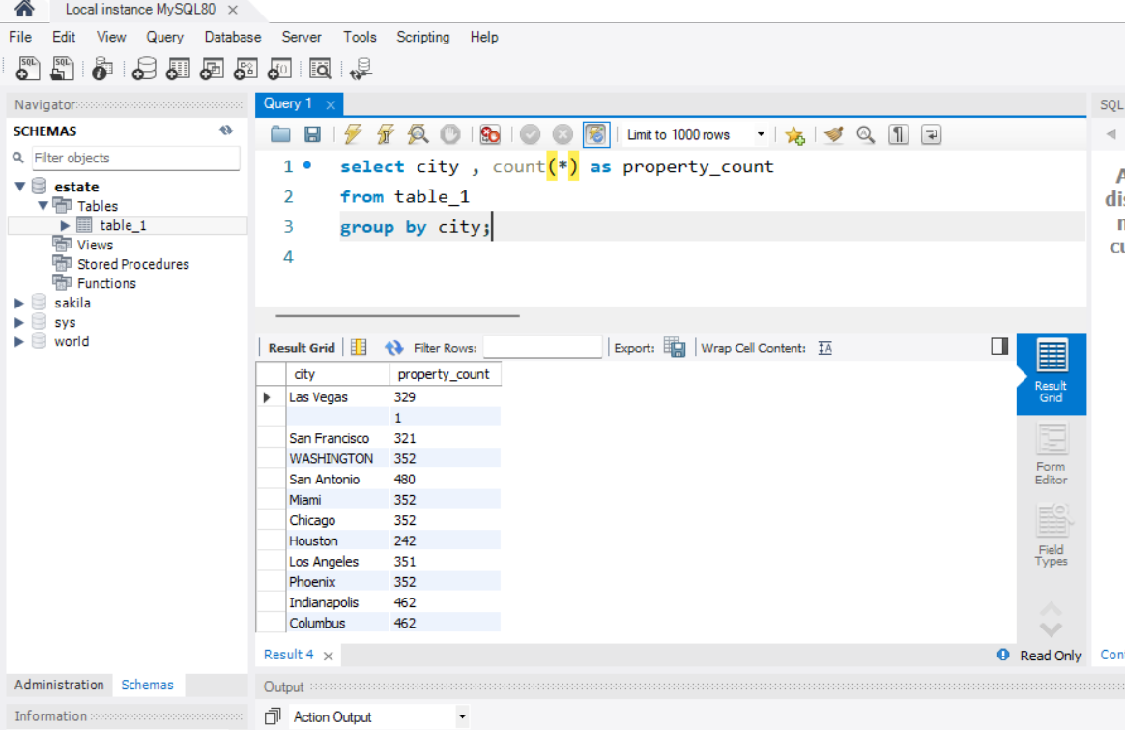

1. Retrieve all properties with at least 3 bedrooms and 2 bathrooms.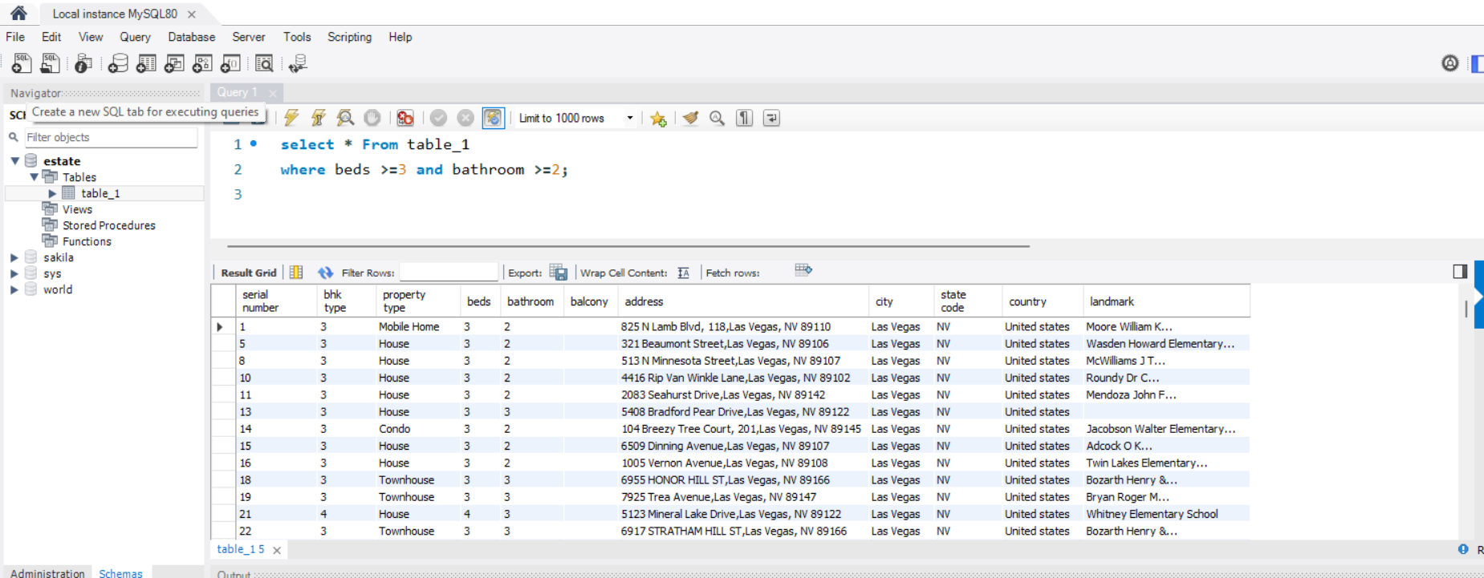

1. Find properties in a specific state with a certain landmark. (take state and landmark on your own ).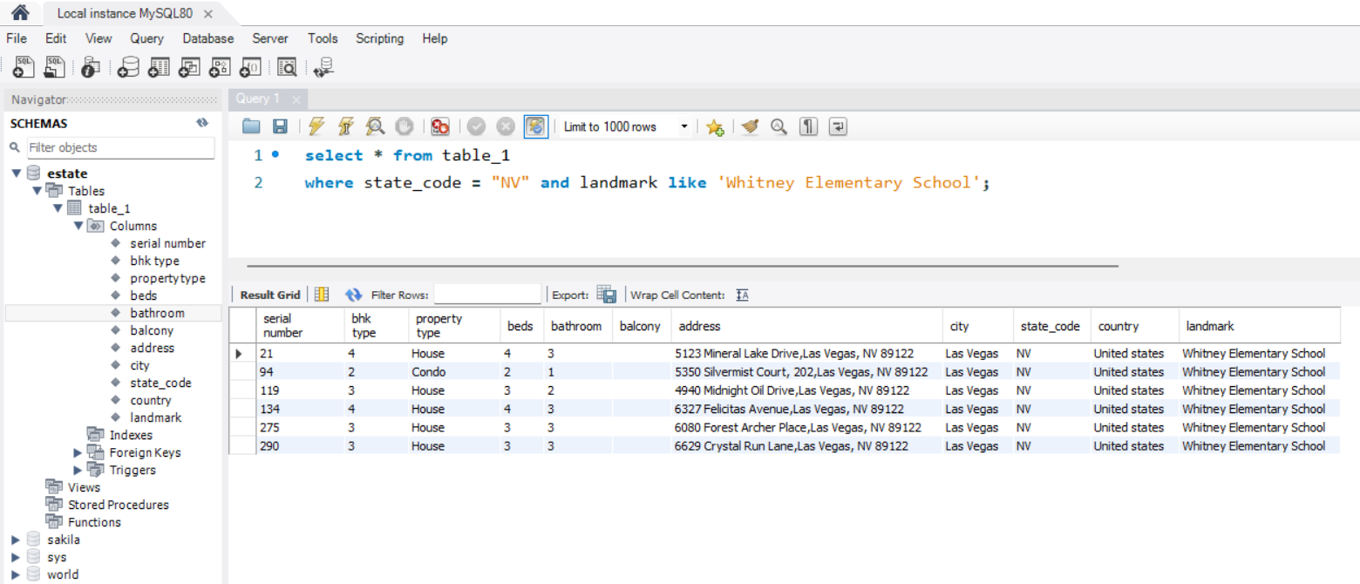

**SQL Query for table 2**

1. Calculate the average price per square foot for properties built before 2010.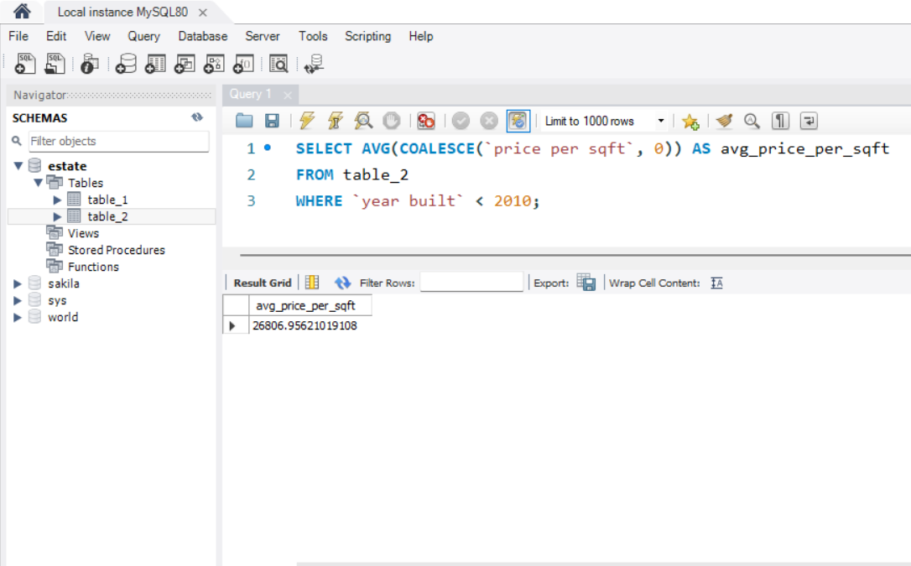

1. Find the total number of properties on each floor.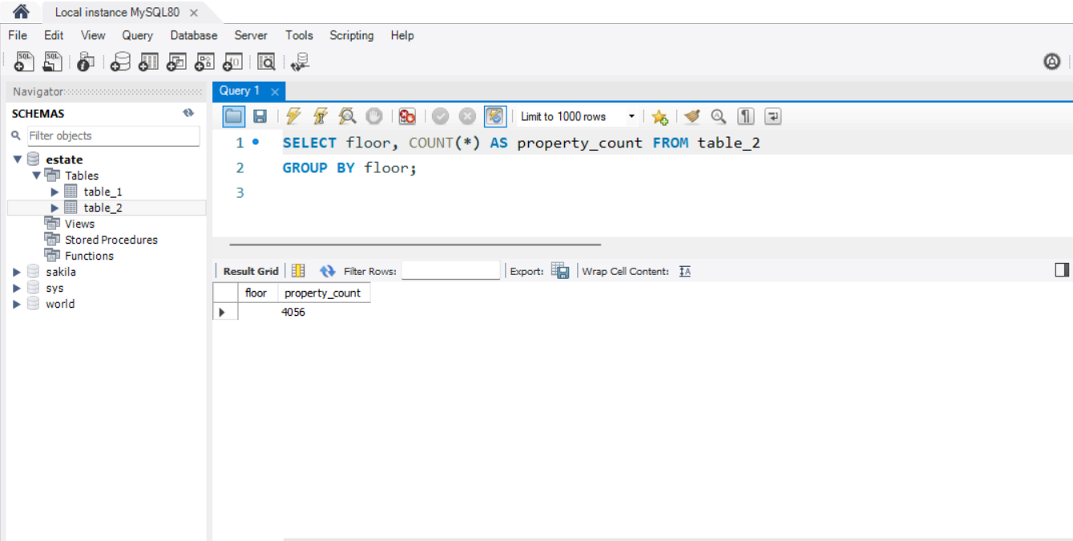
2. Retrieve properties with a carpet area greater than 1000 square feet and a status of 'Under Construction'.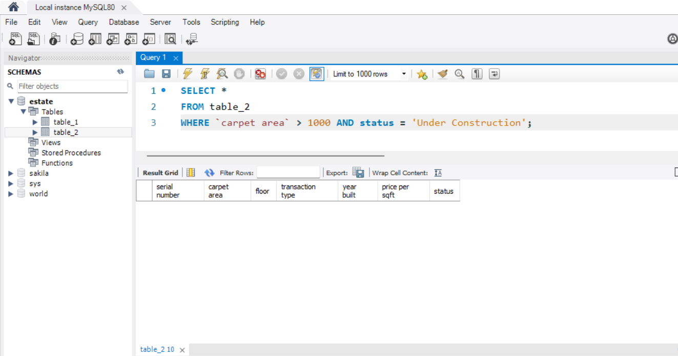
3. Calculate the average price per square foot for each transaction type.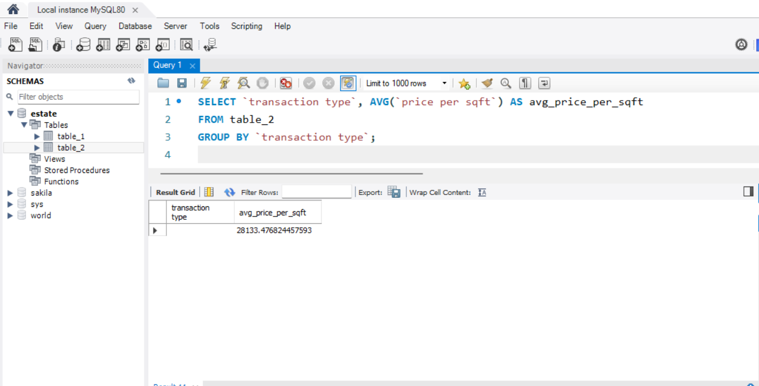
4. Find the properties with the highest price per square foot, sorted in descending order.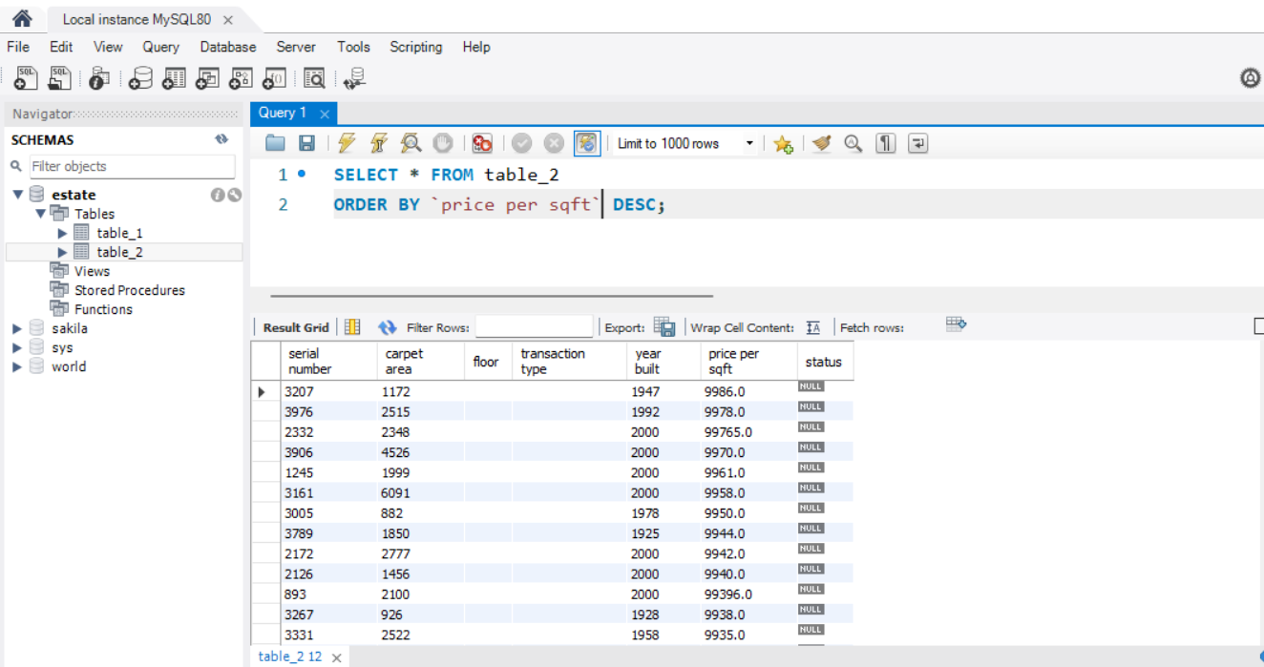

**SQL query for table 3**

1. Retrieve all properties with a furnished status of 'Fully Furnished' and a facing direction of 'East'.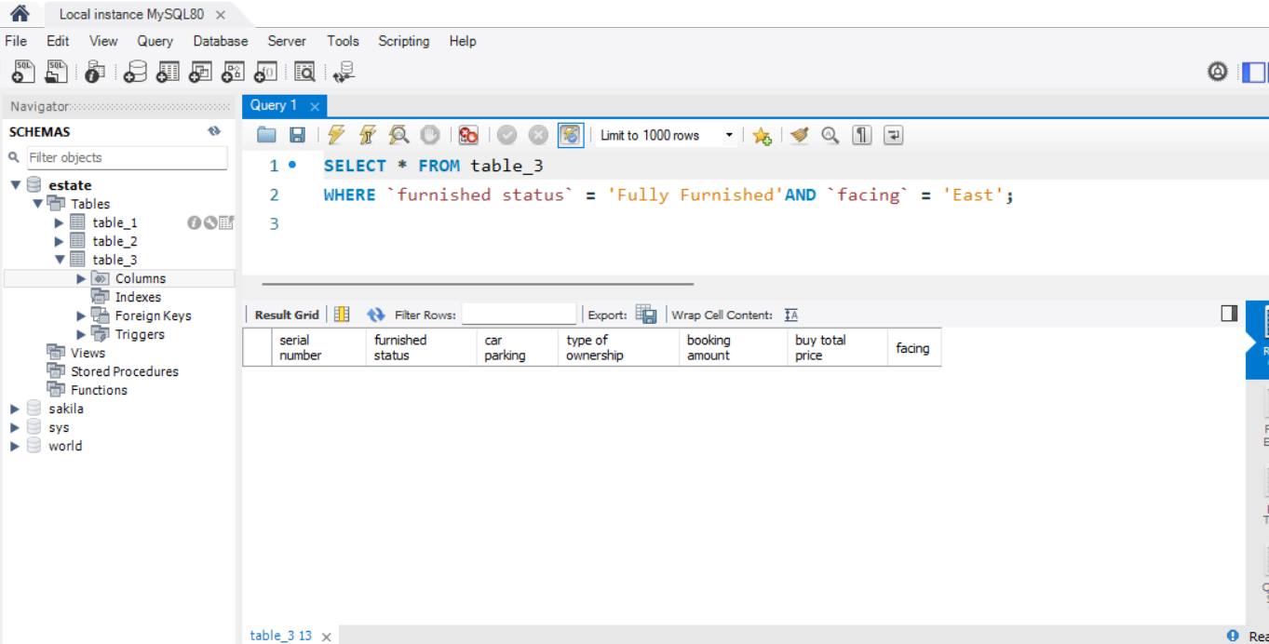
2. Calculate the average booking amount for properties with and without car parking: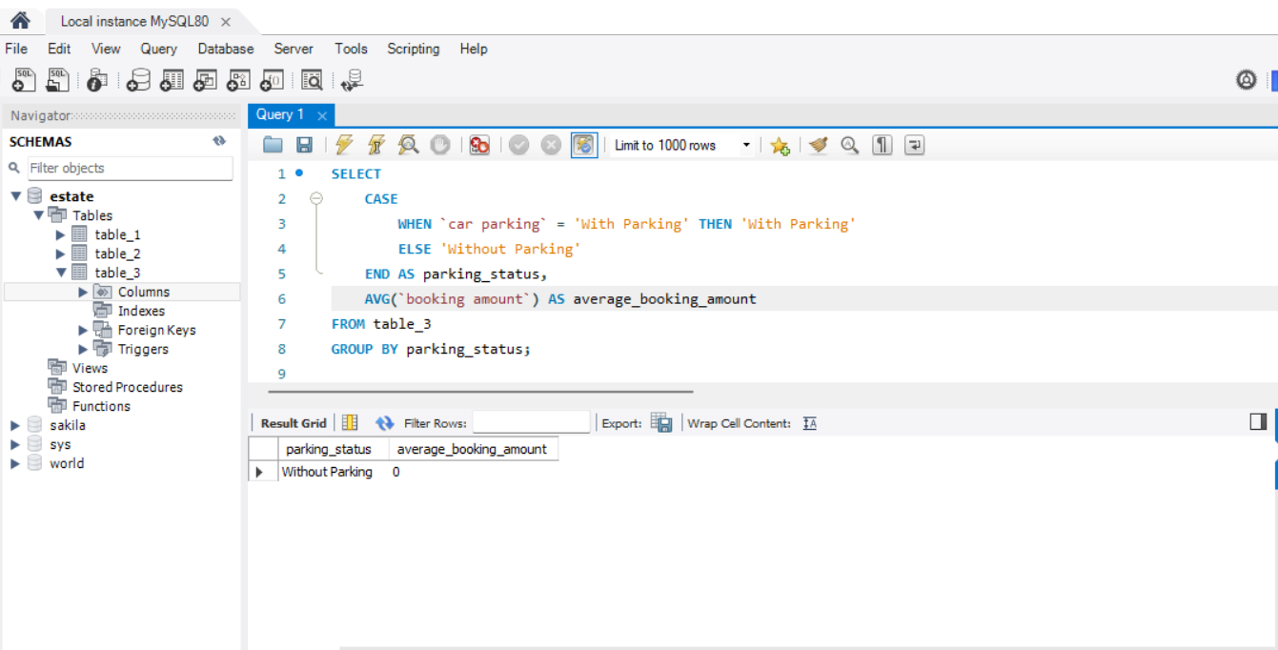

1. Find the total price of properties with different types of ownership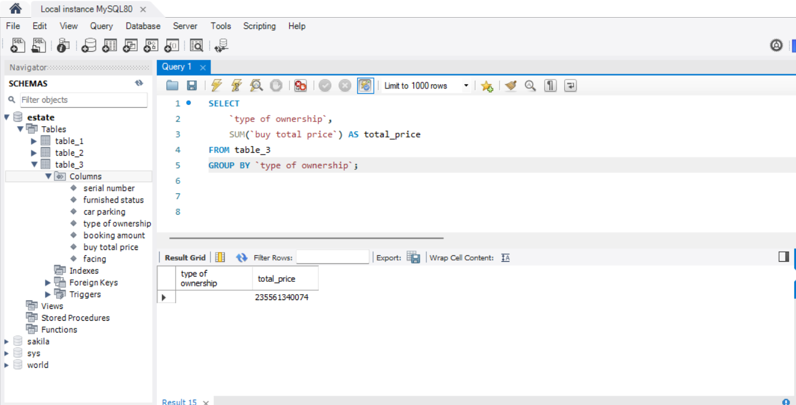
2. Retrieve properties with a booking amount greater than 50000 and a furnished status of 'Semi Furnished'.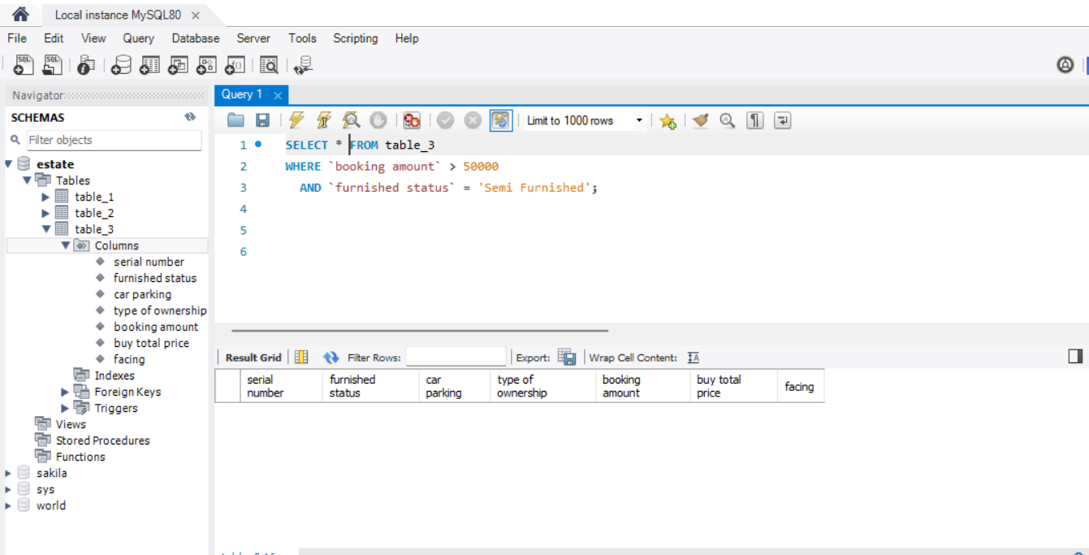
3. Find the property with the highest booking amount.